Lesson 8 Lesson-End Project
Deploy an App to the Kubernetes Cluster

Project Agenda: To deploy a Node.js application on the Kubernetes cluster.

Description: You have created an application and want to containerize it. For efficient load balancing and auto-scaling of the containers depending on the requirement, you decide to deploy your app on a Kubernetes cluster.

Tools required: Node.js/npm, Docker, Kubernetes.

Pre-requisites: You must have installed all the required tools and should have a working Kubernetes cluster setup in order to proceed. In case you do not have it please refer to Lesson 10 Demo 1 to install and setup a Kubernetes cluster.

Expected Deliverables: Create a Node.js application, create a Docker image of the same and create a Kubernetes deployment for it on the cluster and verify its functionality.

Steps to be followed:
- Creating a Node.js application
- Creating a Docker image of the application
- Creating a Kubernetes deployment using a yaml file
- Verifying the deployment of the app on the Kubernetes cluster

Step 1: Creating a Node.js application

- Create a folder in your workspace by executing the below commands:
sudo su
apt install nodejs
mkdir LEP10
cd LEP10
- Create a file named index.js

vi index.js

- Add the following code inside the index.js which will setup a simple server that can be used to test the deployment

const http = require('http');

const port = process.env.PORT || 3000;

const requestHandler = (request, response) => {
console.log('Received request for URL: ' + request.url);
response.writeHead(200);
response.end('Hello World!');
};

const server = http.createServer(requestHandler);

server.listen(port, (error) => {
if (error) throw error;
console.log(`Your app is running on port ${port}`);
});

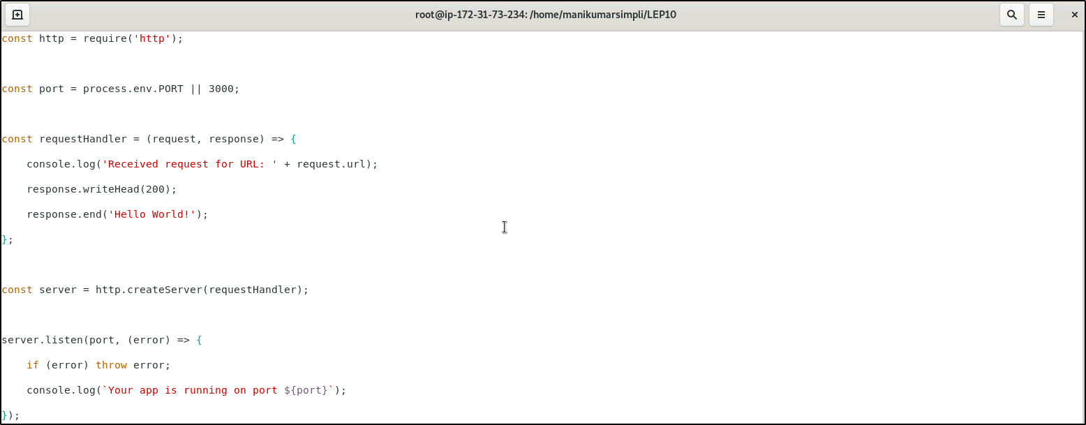

- Run the app to make sure it works fine

node index.js

- From your browser, on navigating to http://localhost:3000 you must be able to see Hello World

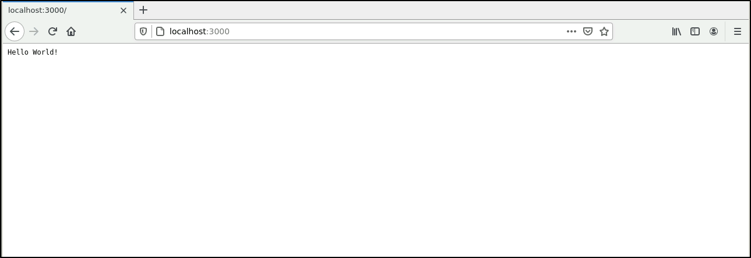

Step 2: Creating a Docker image of the application

- Create a file called Dockerfile by running the following command inside the LEP10 directory:
vi Dockerfile

- Add the following content in the file:

FROM node:carbon

EXPOSE 3000

COPY index.js .

CMD node index.js

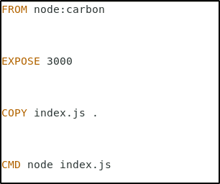

- This image extends the official Node.js image, exposes port 3000, copies index.js file to the image and starts the NodeJs server.

- Build the Docker image using the below command

docker build -t kubernetes-101:v1 .

- The command above will build our image tagged kubernetes-101:v1 using our Dockerfile.
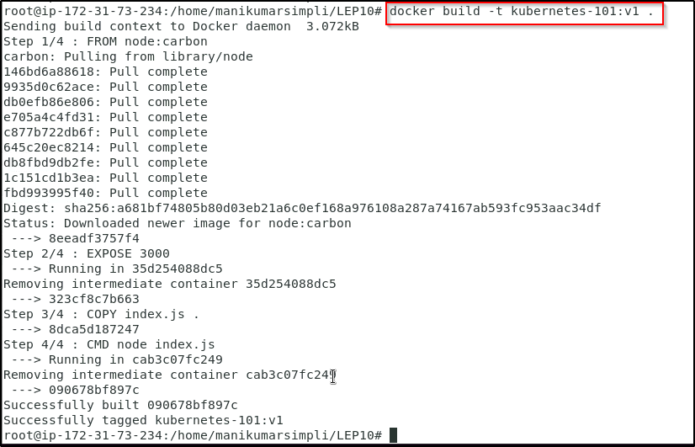

Step 3: Creating a Kubernetes deployment using a yaml file

- Create a file called deployment.yaml

vi deployment.yaml
- Add the following code in the deployment.yaml configuration file

apiVersion: apps/v1
kind: Deployment
metadata:
name: kubernetes-101
labels:
app: kubernetes-101
spec:
replicas: 1
selector:
matchLabels:
app: kubernetes-101
template:
metadata:
labels:
app: kubernetes-101
spec:
containers:
- name: kubernetes-101
image: kubernetes-101:v1
ports:
- name: http
containerPort: 3000

- Run the following command to create a deployment

kubectl create -f deployment.yaml

- Run the below commands to check the deployment that has been created and also to know the details of the same

kubectl get deployments

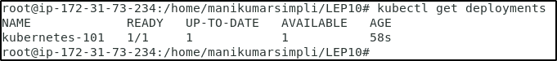

kubectl describe deployments

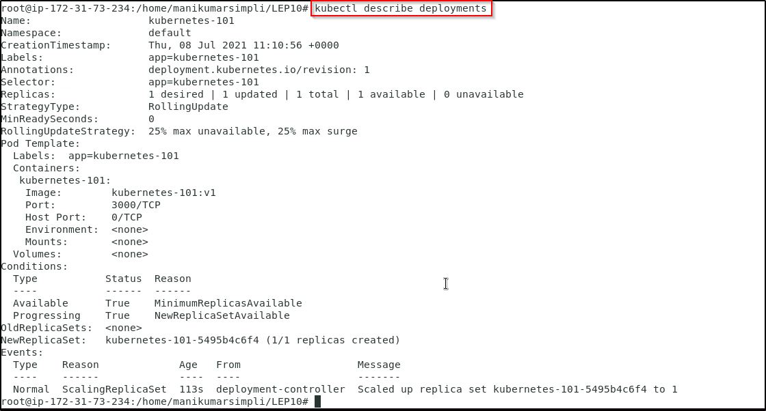

kubectl get pods

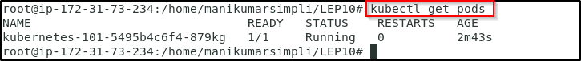

Note: If the pod is in pending state, we need to change the pod status from pending to running state. Execute the below commands:

kubectl get nodes

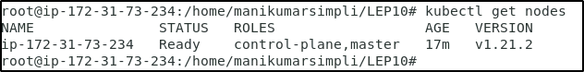
Copy the node name and execute the below command using the copied node name

kubectl taint nodes <node name> node-role.kubernetes.io/master-

Run kubectl get pods to check if the pod is running as shown above.

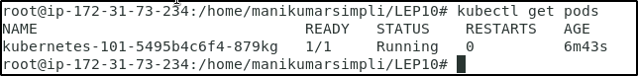

Step 4: Verifying the deployment of the app on the Kubernetes cluster

- We can verify the deployment via Kubernetes port forwarding. Run the following command on the terminal to get the pod name:
POD_NAME=$(kubectl get pods | grep kubernetes-101-* |awk '{ print $1}')

- In order to port forward pod’s port to localhost run the following command:

kubectl port-forward $POD_NAME 3001:3000

- Open another terminal without closing the current one. We should now be able to access the deployed application on the second terminal using the command:

curl localhost:3001

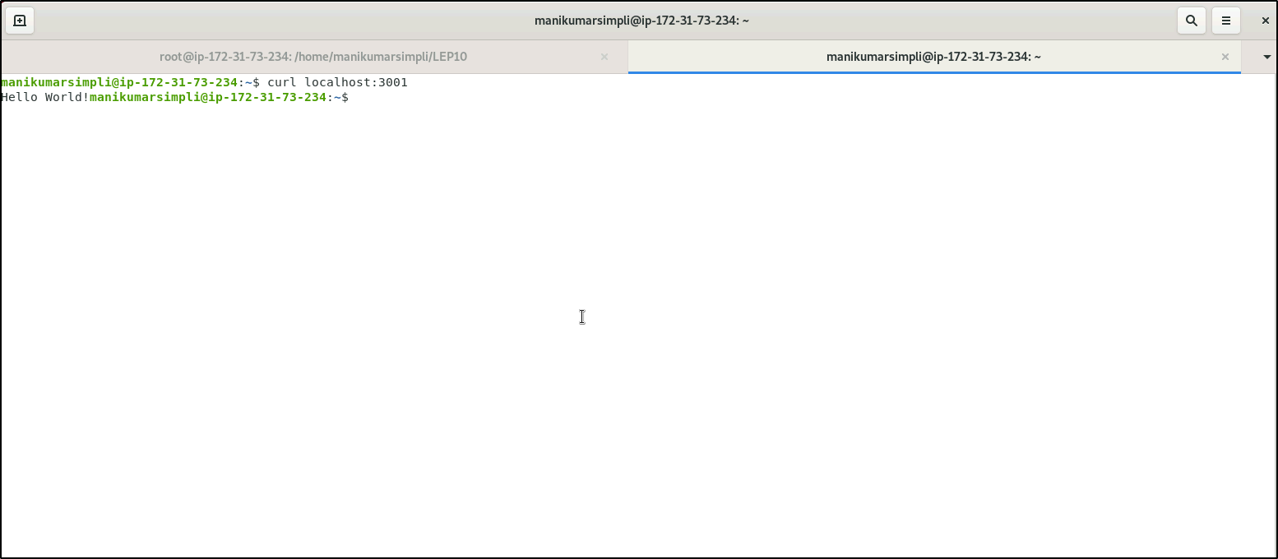

- This confirms that we have successfully deployed the application on the Kubernetes cluster.

